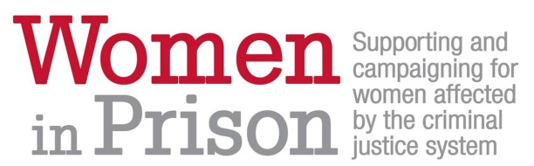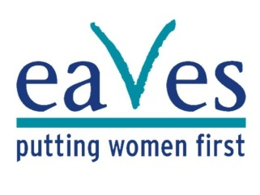


Eaves’ mission is to expose and address violence against women and girls in the UK.
The Beth Centre funded by Lambeth Council is a partnership between Women in Prison, and Eaves for Women. It provides Lambeth women who are either at risk of, or affected by, the criminal justice system, with a holistic set of support services including promotion of from a safe, women only, centre, centrally situated in the borough.

As part of launching the innovative new service we currently have the following opportunity available:

(Female)Volunteer and Peer Mentoring Support Co-ordinator (SP 26-28 £25,515 - £27,009 pa)
Contract to end March 2016
This role will provide co-ordination, training and direct line management support to 30 Peer Support Volunteers a year in addition to supporting ex service users to contribute to the development and delivery of services.

Closing date: Friday 20th March 2015 – 12 noon

Interview dates: 26th March 2015

Volunteer and Peer Mentoring Support Co-ordinator

Please note that Eaves in partnership with Women in Prison actively encourage applications from women who have personal experience of the criminal justice system. Prison clearance is essential for this post, therefore a minimum of 3 years post prison release is required.

Please remember to return the equal opportunities monitoring form and criminal records disclosure form (under separate cover) with your completed application. These posts are all subject to an enhanced DBS check.

Eaves offers a generous 30 days’ annual leave (pro rata) and a pension scheme. You can expect support through regular supervision and a training and development plan.

You can find out more about Eaves and its projects, and also apply on line or download the recruitment pack by visiting our website www.eavesforwomen.org.uk. You can also obtain a recruitment pack by emailing recruitment@eavesforwomen.org.uk or calling 0207 840 7124 (please state clearly the post you are applying for).

Due to the sensitive nature of this role we will be considering female applicants only for this post in accordance with the provisions of the Occupational Requirement (Equality Act 2010, Schedule 9 Part 1).

